**Data Destruction on Hard Drives | The Complete Privacy Guide**

The main goal of this procedure is to make sure that everything on your hard disc is unreadable. The process of destroying every bit of data held on hard discs, cassettes, and other electronic media is known as hard drive data destruction. To render the data unrecoverable, appropriate data destruction software must be used to overwrite the available blocks or space.

This is not to be confused with physical destruction. Shredding laptops, printers, smartphones, and hard drives is an example of physical destruction.

**Random Facts About Data Destruction on Hard Drives**

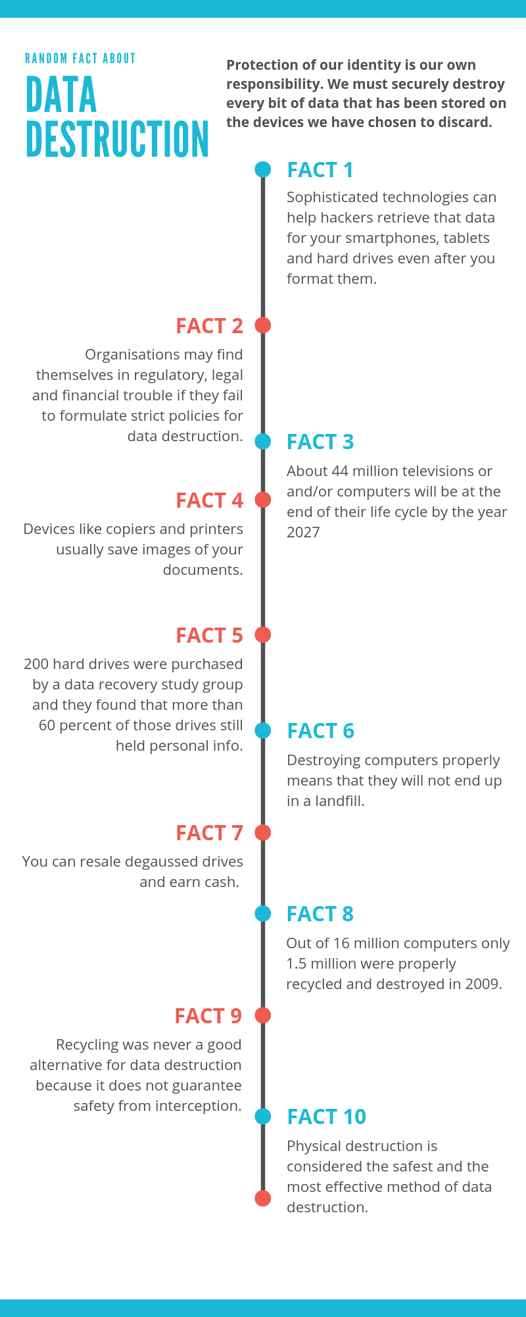

**What is the significance of this?**



Every living soul on the planet should be aware of the significance of safe data erasure on hard drives. We may not want to share some information with everyone since it is personal to us. As a result, we must ensure that all of our data is managed in a compliant and secure manner.

Companies, on the other hand, are required to destroy data in a secure and safe manner. Data destruction is governed by legislation in all regions and countries throughout the world. If you don't follow the rules, you'll be in big trouble.

**Why Should Companies Have a Data Destruction Policy?**

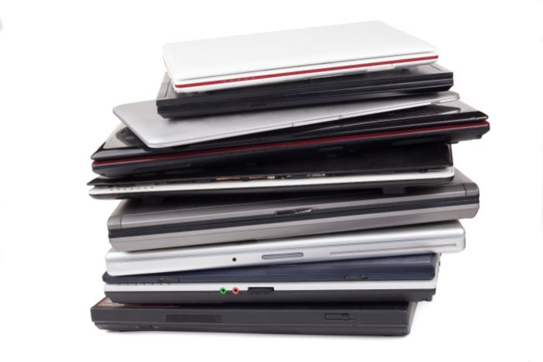

It is not a good idea to throw away old IT equipment such as laptops and tablets. It means you're putting your information at the mercy of dumpster divers. It's like a gold mine of private and confidential information for them.

Putting files in the recycle bin isn't enough. Implementing such a strategy will lessen the risk of a privacy or data breach, as well as prevent you from embarrassment.

**Is Formatting a Hard Drive Solution?**

NO is the answer. Allow me to elaborate.

The majority of individuals assume that formatting clears the slate. This, however, is untrue. In truth, formatting almost always leaves your hard drive's data intact.

The true goal of formatting is to create a new file system by wiping out the old one. It does not delete data in a secure and permanent manner. It might prevent an operating system from reading it, but it doesn't mean the data isn't still there.

Consider your hard disc as a library, and individual files as books. Formatting a hard drive is similar to deleting a library. It may be difficult for you to navigate the library's grounds, but the books will still be available.

It is not necessary to be a technical specialist in order to restore files. With the help of technologies like Ontrack Easy Recovery, anyone can do it.

**Data Destruction Techniques for Hard Drives**

Fortunately, there are multiple ways to erase your data. Learning about these strategies can aid you in determining which one is ideal for you or your company.

**Reformat / Delete**

As I previously stated, formatting or removing data does not totally remove the data from the hard disc. Not unless you utilise a software to fill in the blanks. This method of destruction is unimaginative, inefficient, and unsuccessful.

**Wipe**

If done correctly, this is a secure data removal procedure. Wiping the disc will not only delete all of the data on it, but it will also keep it usable. A wiping device rewrites the spaces with random data several times in this technique. This method cannot be used to recover data from damaged devices.

The procedure takes a long time. It can take up to a day to erase data from a single device. This makes it a viable alternative for a single person, but not for a company.

**Degaussing**

This is the process of erasing data from your device utilising high-intensity electromagnetic waves. However, the procedure may cause your device's delicate mechanisms to malfunction. Your gadget may become inoperable as a result of this type of disturbance. As a result, it is impossible to determine whether or not the data has been erased.

If you want to reuse your gadget, you shouldn't utilise this method.

This technology is becoming obsolete since because SSDs do not store data magnetically.

**Shredding**

It is the most cost-effective and secure way to destroy hard disc data. It may be used to get rid of all kinds of media tapes and hard disc drives. It's incredibly efficient, quick, and safe. Of course, this destroys any possibility of resale or reuse.

I encourage this strategy to companies who deal with sensitive data.

**Physical Destruction:**

Physical destruction isn't limited to shredding. Shooting, pounding, and drilling your equipment are some of the other options. This approach, however, is not impervious to human mistake. This is not a process that can simply be audited.

Furthermore, it does not certain that the drive platters will be destroyed. Large sections of the platter can be left undamaged. If this is the case, recovery software can be used by anyone to retrieve their data.

**Data Erasure**

Do you wish to keep your hard drive? If that's the case, this option is a perfect fit for you. It's ideal for companies that buy off-lease equipment such as laptops and data centres.

**Where Can I Find Trustworthy Data Destruction Services?**

When looking for a data removal service, keep the following considerations in mind:

**Certifications:**

Is there a data destruction certificate provided by the service provider? Ascertain if they adhere to the NCSC's (National Cyber Security Centre) requirements. If that's the case, you can go ahead and do it.

**Recycling:**

Check to see if the IT recyclers are R2 or ISO certified. You must verify whether or not they are capable of properly recycling your gadget.

**Documentation:**

A data destruction service should be able to supply you with authentic documents demonstrating data erasure.

**Check Background:**

Reduce your list to the top three or four services and check customer evaluations. Don't forget to inquire about their experience in this field.

Recycle Pro is committed to assisting you in the disposal of your e-waste. We believe in [secure IT disposal](https://www.recyclepro.co.uk/) and provide our clients with secure data and hard drive destruction services. We meet all HMG requirements and, as promised, issue a certificate of assurance.